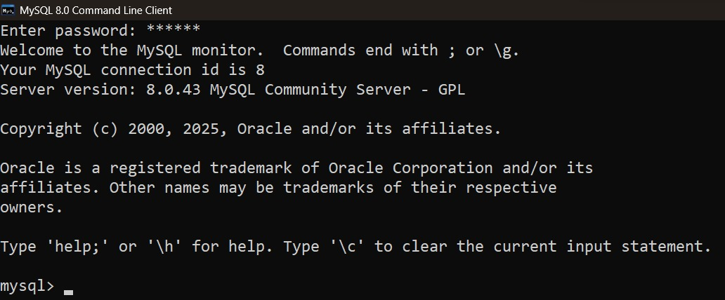
- Install MySQL Community Server on your computer and take a screenshot of the MySQL installer completion window.

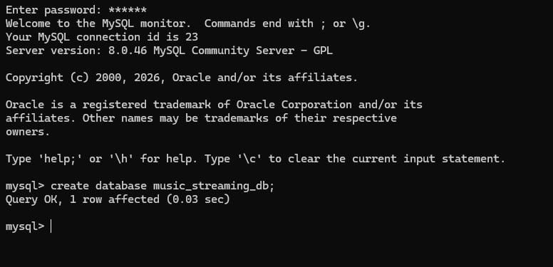
- Open MySQL Workbench or DB Browser, connect to your local MySQL server, and create a new database called music_streaming_db

- Write the SQL command to create a new database named food_delivery_db and execute it in your SQL Workbench or Browser.<br><br><em><strong>Hint:</strong> Use the CREATE DATABASE statement.</em>
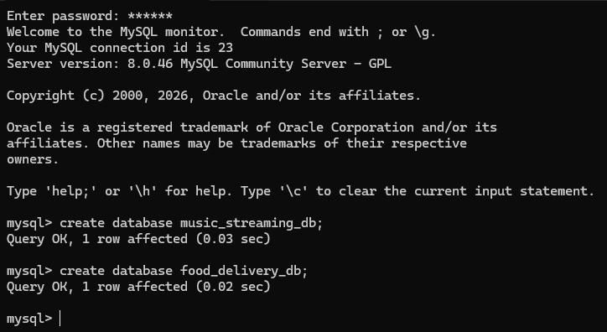

- List 3 differences between MySQL and PostgreSQL in terms of features or use cases, and give one example of a popular app or company that uses each.
 | MySQL | PostgreSQL
1. Main strength | Known for being simple, fast, and easy to use for common web applications. | Known for advanced features and complex data operations.
2. Data & SQL features | Supports relational data and common SQL operations; often preferred for straightforward applications. | Has strong support for complex queries, advanced data types, JSON, and extensibility.
3. Typical use cases | Commonly used for websites, e-commerce, and content-management systems. | Commonly used for analytics, complex applications, GIS, and systems needing advanced database capabilities.

